1.1-what is testing
start at 5:01
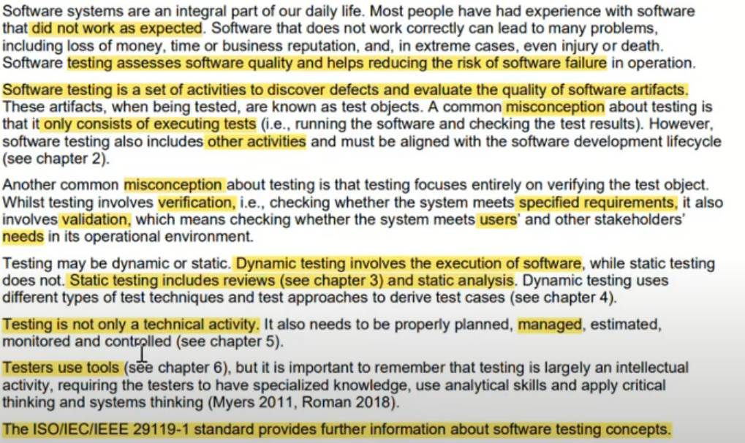

1.1.1-Test Objectives
start at 13:30
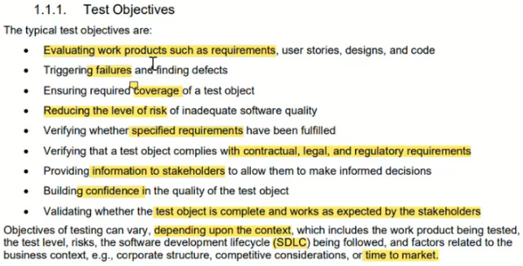

1.1.2-Testing and Debugging
start at 25:09
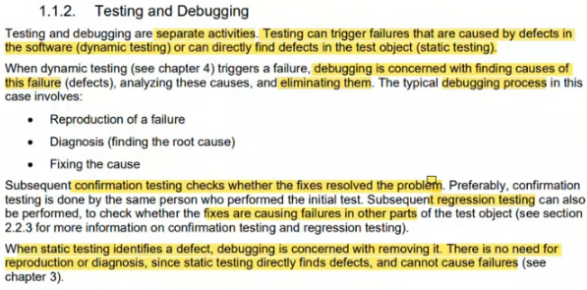

1.2-Why is testing Necessary
start at 29:57
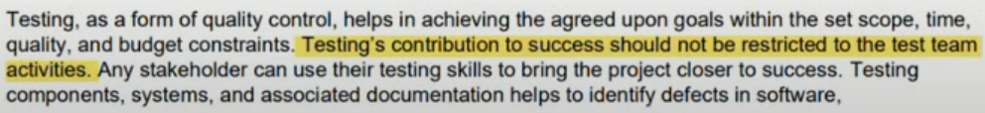

1.2.1-Testing’s Contributions to Success
start at 30:37
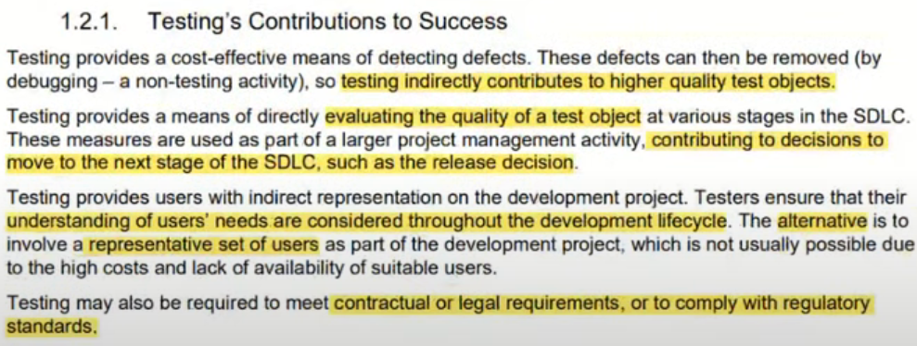

1.2.2-Testing and Quality Assurance (QA)
start at 33:22
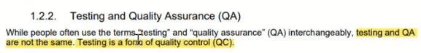
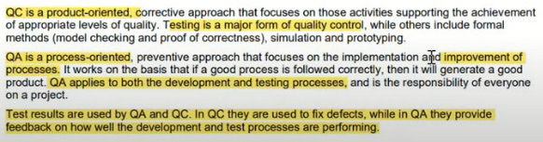

1.2.3-Errors, Defects, Failures and Root Causes
start at 37:44
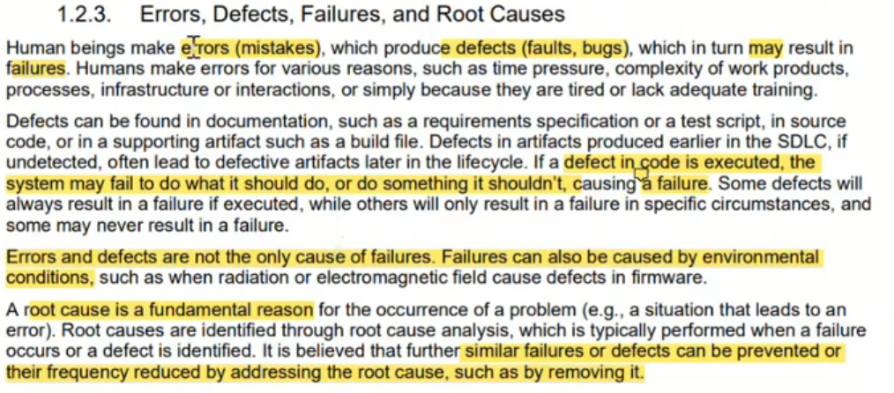

1.3-Testing Principles
start at 42:32
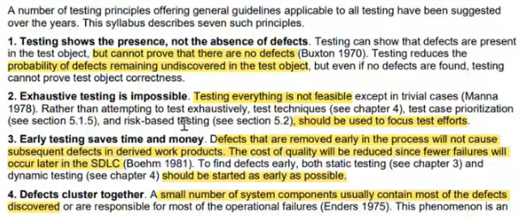
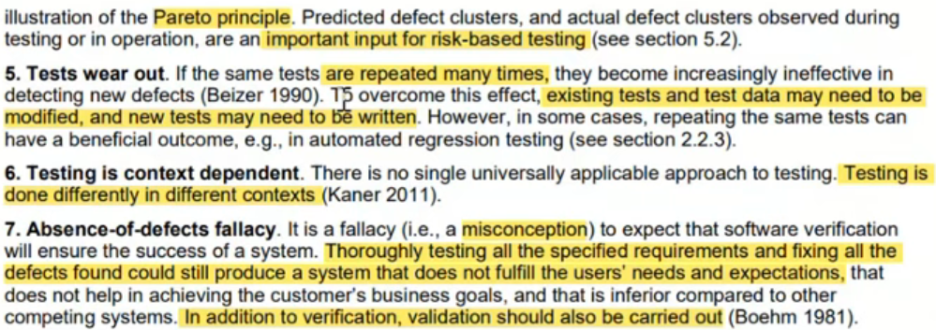

1.4-Test Activities, Testware and Test Roles
start at 52:02
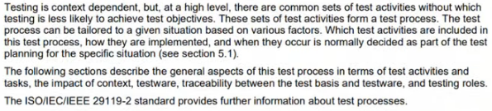

1.4.1-Test Activates and Tasks
start at 52:02
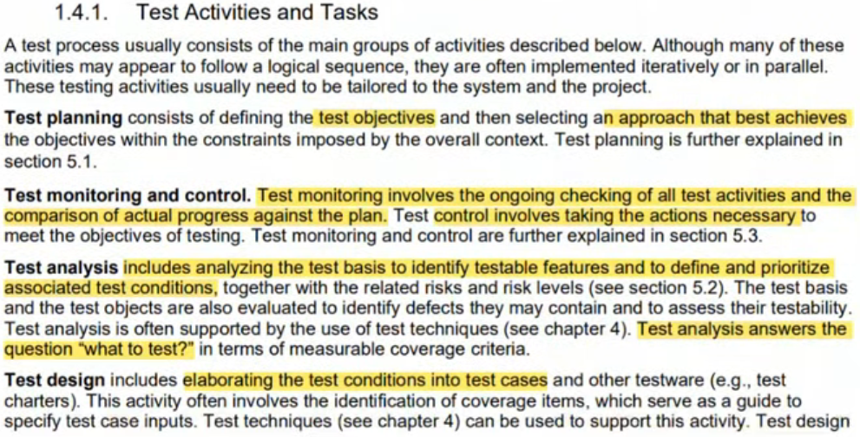
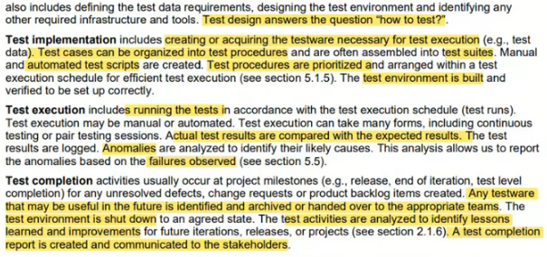

1.4.2-Test Process in Context
start at 1:06:00
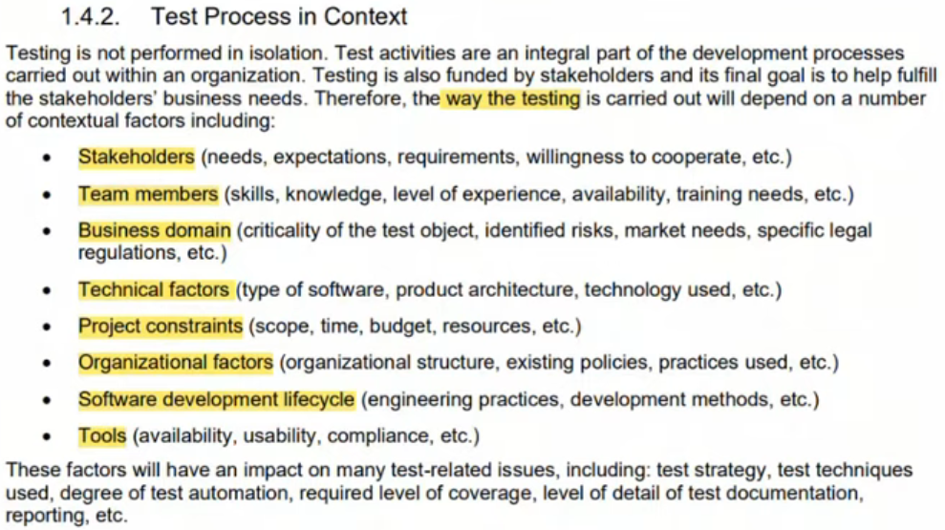

1.4.3-Testware
start at 1:10:04
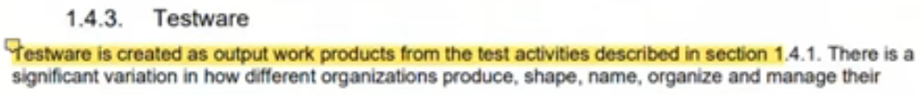
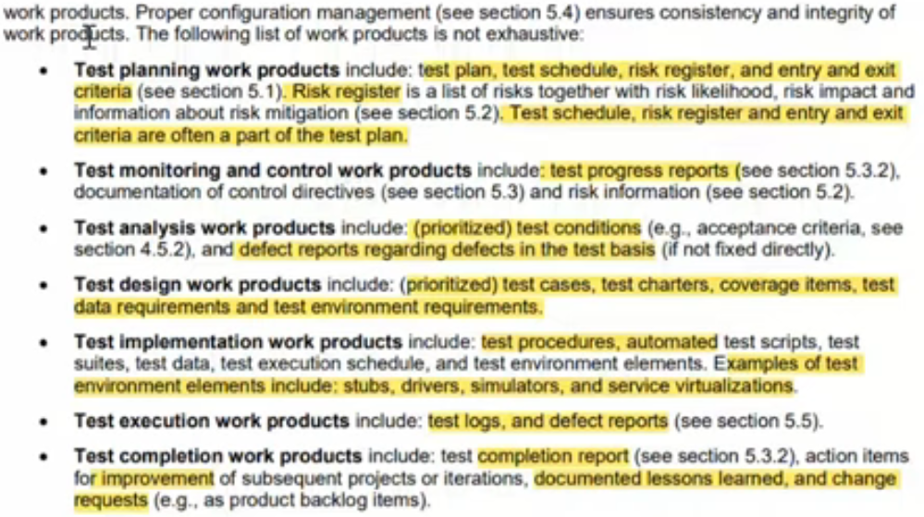

1.4.4-Traceability between the Test Basis and Testware
start at 1:20:35
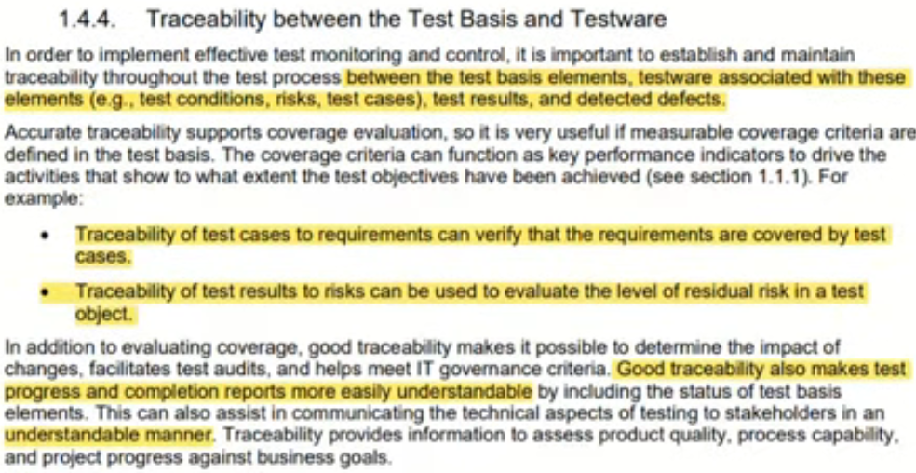

1.4.5-Roles in Testing
start at 1:23:23
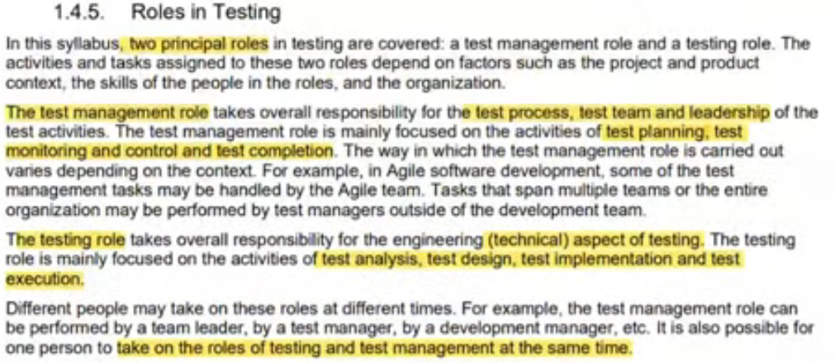

1.5-Essentials Skills and Good practices in Testing
start at 1:25:27
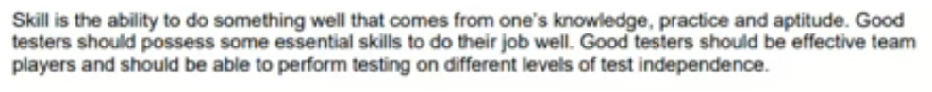

1.5.1-Generic Skills Required for Testing
start at 1:25:27
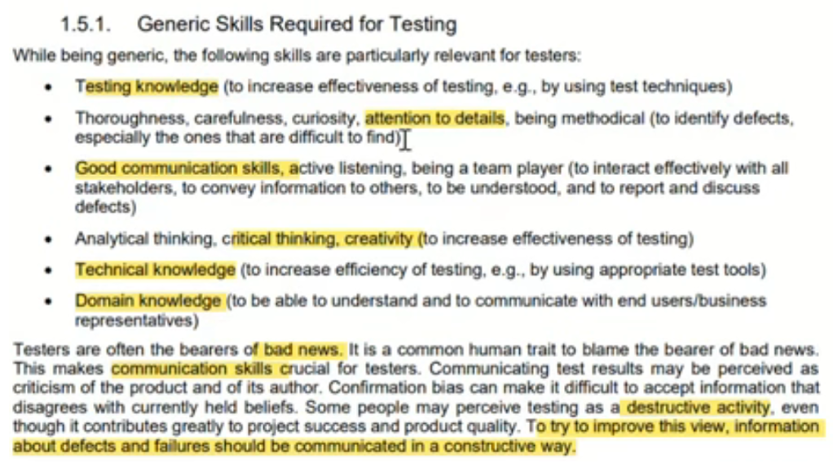

1.5.2-Whole Team Approach
start at 1:29:10
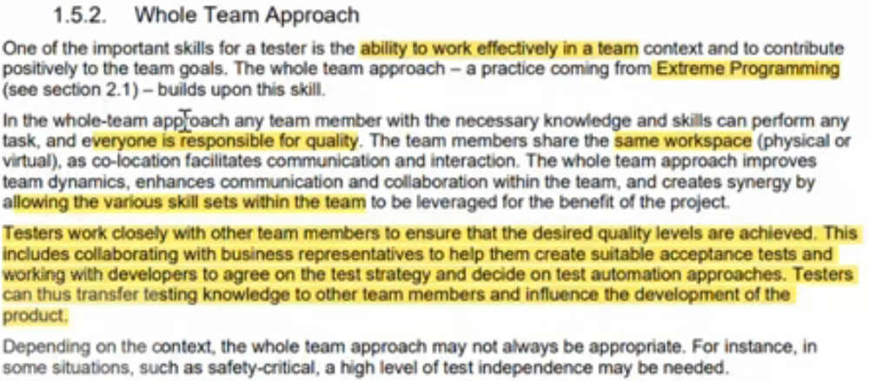

1.5.3-Independence of Testing
start at 1:31:17
